Computing Assignment 7

Daniel Todd

301428609

D100

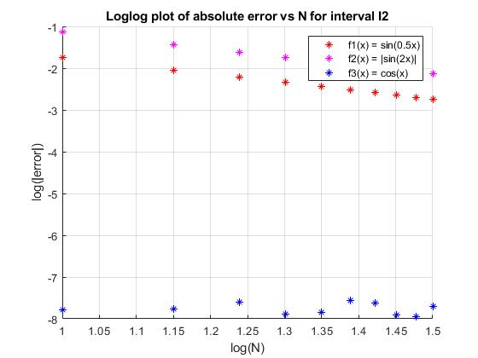 In this computing assignment I approximated the integral of functions using the composite trapezoidal rule. I first approximated $\int_{0}^{1}{x^{3}dx}$ with $N=100$ as a test case. I found the value of this integral to be $\int_{0}^{1}{x^{3}dx} ≈ 0.250025$. I then approximated the integrals of 3 functions: $f_{1}=\sin\left(\frac{1}{2}x\right), { f}_{2}\left(x\right)=\left|\sin\left(2x\right)\right| and, f_{3}\left(x\right)=\cos\left(x\right)$ over two intervals: $I_{1}=\left[0, \frac{π}{3}\right], I_{2}=\left[0, 2π\right],$ for $N=\{100, 200, …, 1000\}$. I then calculated the absolute error of each approximation for all N onto two loglog plots, one for each interval. These loglog plots can be found below.

In plotting the absolute error of each approximation vs N onto a loglog plot, I easily found the rate of growth for each approximation’s error by taking the slope of the best fit linear line of each dataset on the loglog plot. I then found the rate of convergence for each approximation by simply taking the negative of each approximation’s rate of growth. The rate of convergence for the error of each approximation can be seen to the right. In calculating these convergence rates, it appears that the highest rate is for the approximation of $\int_{0}^{2π}{\left|\sin\left(x\right)\right|dx}$ at an error convergence rate of $O(h^{2.000093756800}$). However, though the approximation of $\int_{0}^{2π}{\left|\sin\left(x\right)\right|dx}$ has the highest error convergence rate, the approximation of $\int_{0}^{2π}{\cos\left(x\right)dx}$ was actually the fastest approximation to reach an error close to machine epsilon, as seen in the loglog plot for interval $I_{2}$. When looking into the trapezoidal rule on the [wikipedia](https://en.wikipedia.org/wiki/Trapezoidal_rule). A small section of the page named “Applicability and alternatives” notes “ the trapezoidal rule tends to become extremely accurate when periodic functions are integrated over their periods”. This explains the extreme accuracy of $\int_{0}^{2π}{\cos\left(x\right)dx}$, as the period of $f\left(x\right)=\cos\left(x\right)$ is $2π$.